LIMERICK CHAMBER REGIONAL BUSINESS AWARDS

BEST CONTRIBUTION TO THE COMMUNITY (CSR) AWARD OF THE YEAR AWARD 2019

Application Form

Sponsored by: Overall Sponsors:
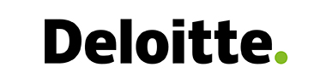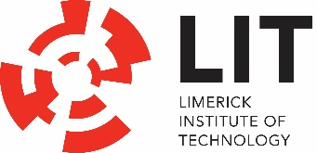

I hereby state there is no known conflict between this applying company with the sponsor of this award- Deloitte

Signed:_____________________________
Print Name:________________________________
Date: _______________________________

LIMERICK CHAMBER REGIONAL BUSINESS AWARDS

BEST CONTRIBUTION TO THE COMMUNITY (CSR) AWARD OF THE YEAR AWARD 2019

Application Form

Sponsored by: Overall Sponsors:

The Limerick Chamber Regional Business Awards will award The Best Contribution to the Community (CSR) of the Year Award to an organisation, trading at least 12 months based in the Mid-West Region, that demonstrates significant positive impact on the community. This can be in a variety of areas such as those that have a social, economic, environmental or cultural impact. The Contribution to the Community (CSR) Award recognises an organisation who has significant positive impact in the community, CSR forms part of the key values/principles of the company and it is known to employees with a structure in place to enable continuous engagement with the community.

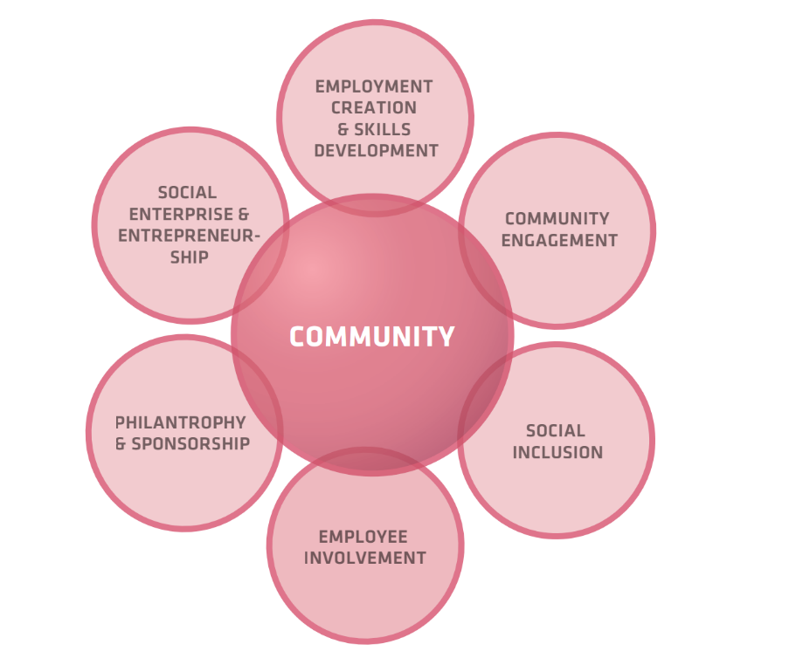
The DBEI publication ‘Good for Business, Good for the Community’ states that a key priority for a socially responsible business is to develop and maintain strong and mutually beneficial relationships with its community. It is at the local and community level that the impact of increased CSR activity will be felt in social, economic or environmental terms. Using scarce resources efficiently, helping people to develop their potential and building self-reliant communities are all part of the benefits that will be seen when businesses embed CSR practices into their mainstream operations. Respectful consultation, participation and collaboration with local communities brings a host of benefits to the enterprise as well as to the community. An active interest in the community by a business can generate community support, goodwill and loyalty. There are many ways in which enterprises are involved in communities in Ireland through proactive social inclusion projects, outreach programmes, staff volunteering initiatives, support for broader health and wellbeing programmes, fundraising, mentoring, etc.

Eligibility
To be eligible for the Best Contribution to the Community (CSR) Award, nominees must have been in operation for a minimum of 12 months in the Limerick City Region. They can be an SME or Large company including a multinational. Not for profit organisations cannot apply for this award – see Best Not for Profit Award.

Judges will be looking at:
- Innovation: Projects avoid stereotypical actions and make an effort to think outside of the box when addressing the relevant issues. Projects are capable of adapting as they progress.
- Engagement & Collaboration: Projects engage staff at all levels of the company and involve knowledge or skills sharing. There is strong and mutually beneficial collaboration with any partner charities, communities or other stakeholders.
- Strategy & Communications: Projects involve clear identification and prioritisation of goals and actions, and effective communications with all stakeholders.
- Social Impact: Projects have demonstrable, positive, long term impact on the relevant stakeholders and are sustainable.
- Business Impact: The company and staff benefit from engagement in the project. CSR projects support and complement core business strategy.

Application Questions
To win this award applicants will need to provide:
- An executive summary describing the company, key team, the market it operates in and product/service it offers outlining their value proposition (max. 300 words)
- Describe the CSR goals and strategy in place with a focus on contribution to the community. (max. 500 words)
- Explain how employees are encouraged to engage in CSR, the impact it has on the culture of the company and give examples where possible (max. 500 words)
- Describe one or more projects that the business has been involved in over the last 12 months demonstrating the positive, long term impact to the relevant stakeholders (max. 500 words) photographs/video coverage of projects that can be shared are welcome).
- Describe how the company and staff benefit from engagement in the project (max. 300 words)
- Describe how this award would be of benefit to the business (max. 300 words)

I hereby state there is no known conflict between this applying company with the sponsor of this award- Deloitte

Signed:_____________________________
Print Name:________________________________
Date: _______________________________

