LIMERICK CHAMBER REGIONAL BUSINESS AWARDS

BEST BUSINESS: EMPLOYEE TALENT DEVELOPMENT & WORKPLACE WELLNESS OF THE YEAR 2019
No Conflict Statement

Sponsored by: Overall Sponsors:
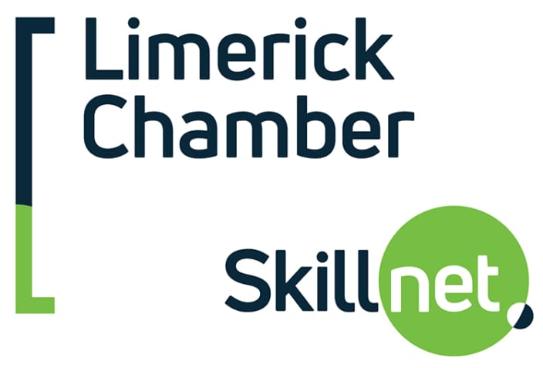

I hereby state there is no known conflict between this applying company with the sponsor of this award- Limerick Chamber Skillnet

Signed:_____________________________
Print Name:________________________________
Date: _______________________________

LIMERICK CHAMBER REGIONAL BUSINESS AWARDS

BEST BUSINESS: EMPLOYEE TALENT DEVELOPMENT & WORKPLACE WELLNESS OF THE YEAR 2019

Application Form

Sponsored by: Overall Sponsors:

The Limerick Chamber Regional Business Awards will award The Best Business: Employee Talent Development & Workplace Wellness of the Year award to an organisation, trading for more than 2 years in the Mid-West Region, that is striving to create a world class environment for their employees, setting the highest standards in talent development and personal wellness. This award recognises the organisation that has excelled in this area demonstrating enterprise-wide success as a result of embedded and consistent employee talent development and tailored wellness support.

In today's competitive global job market, being a well-known organisation or having a famous consumer brand name is not enough to attract and retain top talent and even more challenging if you are a small, yet unknown company with opportunities to grow globally with the right team. Organisations need to actively promote their strengths, and demonstrate why they should be considered a preferred employer to work for.

Eligibility
To be eligible for the Best Business: Employee Talent Development & Workplace Wellness of the Year, nominees must have been in operation for a minimum of 24 months based in the Limerick City Region (Mid-west region) and must qualify as either an SME or Large (including multinationals).

Judges will be looking at:
- Executive Support: The winning business will have demonstrated that the executive team supports the role of the talent development function in the organisation and the wellness & personal development function of the organisation and consider it to be a strategic driver of the business and that the programmes/supports they offer are tailored for their employees.
- Culture: The winning organisation will have demonstrated that talent development and workplace wellness is a valued part of the culture of the organisation and that employees take up on the opportunity to develop both personally for wellness and professionally in terms of talent development
- Innovation. The winning organisation will have provided evidence of innovative thinking in their approach to support their employees and that they are on the leading edge of best practices for supporting the development of the employees and that the quality of the supports offered are of the highest standards
- Link between training & development and business performance: The winning organisation will have provided evidence that there is a link between their talent development and wellness programmes/strategy and the results they are achieving in the business

Application Questions
To win this award applicants will need to provide:

- An executive summary describing the company (its vision/mission), the market it operates in and the leadership team (max. 300 words)
- Describe what the talent development and workplace wellness supports/programmes are and how the executive team supports this in the organisation (max. 500 words. Web links to programmes/supports available to employees are welcome)
- Describe the culture of the organisation and give examples where employees have taken up on the opportunity to develop both personally for wellness and professionally in terms of talent development (max. 500 words – it is ok to use anonymous rather than naming employees. Testimonials are welcome however and can be included in an appendix or quoted in this section. Videos are a welcome addition but should be short – these are looked at in addition to the written answer to this question not as an alternative)
- Provide evidence of innovative thinking in the organisations approach to support its employees (max. 300 words)
- Provide evidence that there is a link between the organisations talent development and wellness programmes/strategy and the results it is achieving in the business (max. 300 words)
- Describe how this award would be of benefit to the business (max. 300 words)

I hereby state there is no known conflict between this applying company with the sponsor of this award- ActionPoint

Signed:_____________________________
Print Name:________________________________
Date: _______________________________

