LIMERICK CHAMBER REGIONAL BUSINESS AWARDS

BEST NOT FOR PROFIT ORGANISATION AWARD 2019

No Conflict Statement

Sponsored by: Overall Sponsors:
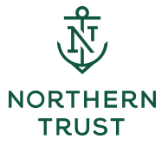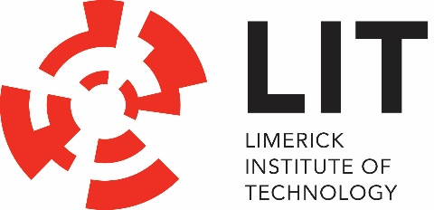

Note: Photographs/video coverage of projects that can be shared are welcome
I hereby state there is no known conflict between this applying company with the sponsor of this award- Northern Trust

Signed:_____________________________
Print Name:________________________________
Date: _______________________________

LIMERICK CHAMBER REGIONAL BUSINESS AWARDS

BEST NOT FOR PROFIT ORGANISATION AWARD 2019

Application Form

Sponsored by: Overall Sponsors:

The Limerick Chamber Regional Business Awards will award The Best Not for Profit Organisation of the Year Award to an organisation, in operation for at least 12 months based in the Mid-West Region, that demonstrates significant positive impact on the community it serves. This can be in a variety of areas such as social, economic, environmental or cultural impacts.

Eligibility
To be eligible for the Best Not for Profit Organisation Award, nominees must have been in operation for a minimum of 12 months, based in the Limerick City Region. Though it is a highly diverse sector, the organisations generally share the following features:
- Organised: distinguished from informal or ad hoc, purely social or familial groupings by having an institutional presence or structure;
- Non-profit distributing: do not return profits to a set of managers or owners;
- Independent: not a state agency/organisation (however funding from state aid or local government and other supports (including positions on boards) is acceptable);
- Voluntary: containing some element of voluntary or unpaid participation;
- Self-governing: in control of their own affairs; and
- Contributing to the public good: their activity aimed, at least in part, at contributing to the public good.

Judges will be looking at:
- Innovation: the organisation avoids stereotypical actions and makes an effort to think outside of the box
- Compelling Need: The organisation demonstrates that it is meeting a compelling need(s) in the community it serves
- Engagement & Collaboration: The organisation can demonstrate that it engages with its community and key stakeholders at all levels in the development of its services. There is strong and mutually beneficial collaboration with any partner charities, NGO’s, communities or other stakeholders.
- Social Impact: Projects have demonstrable, positive impact on the relevant stakeholders and are sustainable.
- Future Development and governance: organisations demonstrate potential for future development, growth and sustainability and shows that the organisation demonstrates excellence in governance

Application Questions
To win this award applicants will need to provide:
- An executive summary describing the organisation, key team and services it offers outlining the value it offers to the community (max. 500 words)
- Describe the organisations goals and strategy and how it is meeting its objectives over the last 12 months. (max. 500 words)
- Explain how the team and any volunteers are organised and supported to maximise impact (max. 500 words)
- Describe one or more projects that the organisation has lead or been involved in over the last 12 months demonstrating the positive impact to the relevant stakeholders, please provide testimonials where possible as an appendix or quote within this section (max. 1,000 words)
- Describe how the organisation excels in the area of governance (max. 300 words)
- Describe how this award would be of benefit to the organisation (max. 300 words)

Note: Photographs/video coverage of projects that can be shared are welcome
I hereby state there is no known conflict between this applying company with the sponsor of this award- Northern Trust

Signed:_____________________________
Print Name:________________________________
Date: _______________________________

