LIMERICK CHAMBER REGIONAL BUSINESS AWARDS

BEST SME OF THE YEAR 2019

Application Form

Sponsored by: Overall Sponsors:
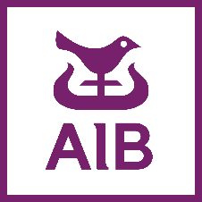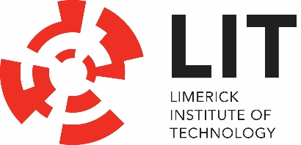

I hereby state there is no known conflict between this applying company with the sponsor of this award- AIB

Signed:_____________________________
Print Name:________________________________
Date: _______________________________

LIMERICK CHAMBER REGIONAL BUSINESS AWARDS

BEST SME OF THE YEAR 2019

Application Form

Sponsored by: Overall Sponsors:

The Limerick Chamber Regional Business Awards will award The Best SME of the Year award to an organisation, trading for more than 3 years, based in the Mid-West Region, that is striving to create world class products and services, setting the highest benchmarks and optimising opportunities in their market place.

Eligibility
To be eligible for the Best SME Award, nominees must have been in operation for a minimum of 5 years (see Best Emerging Business for < 5 years) and at least 12 months in the Limerick City Region (Mid-west region). The European definition of SME applies and is as follows: "The category of micro, small and medium-sized enterprises (SMEs) is made up of enterprises which employ fewer than 250 persons and which have an annual turnover not exceeding 50 million euro, and/or an annual balance sheet total not exceeding 43 million euro”.

Please note that if your company forms part of a multinational organisation then it is the multinational organisation that must meet the criteria. In some cases, this might mean that you apply for Best Large Business and focus on the local impact and your company will be assessed in that context.

This category excludes retail & hospitality businesses. Please see the other award category for this.

Judges will be looking at:
- Innovation: The winning business demonstrates how has the company embraced research, development and innovation to strengthen its competitiveness and grow its market share or into new markets
- Viability: This winning business demonstrates a significant growth opportunity in their sector/marketplace along with a clear mission, vision and strategy.
- Growth & Developments: Evidence of impressive performance and achievement in the last 12 months coupled with planning for growth and acting upon opportunity in the market
- Contribution to the Region: The winning business will have had a positive impact to the region in areas such as job creation, supporting the culture of collaboration and support with other businesses and organisations in the region, helping to attract new investment, have a culture that embraces corporate giving in their community.

Application Questions
To win this award applicants will need to provide:
- An executive summary describing the company (its vision/mission), the market it operates in and the leadership team (max 300 words)
Click or tap here to enter text.

- Demonstrate how has the company has embraced research, development and innovation to strengthen its competitiveness and grow its market share or into new markets. (max. 300 words)
Click or tap here to enter text.

- Clearly identify the problem the company sets out to solve or need it is addresses and how their solution is solving the problem or meeting the need – demonstrate a compelling value proposition supporting growth in the business in the last 12 months. (max. 300 words)
Click or tap here to enter text.

- Provide proof/examples of how customers are benefiting from the business (max. 500 words).
  - For B2B: Explain how customers/users experience the positive impacts of the adoption process in areas such as increases in efficiency, revenue and has this helped to create jobs or had an impact in terms of advancing how businesses are working in their sector.
  - For B2C: Explain how customers/users experience the positive impacts of the adoption process and how the product/service is meeting a compelling need
Click or tap here to enter text.

- Provide details of impressive performance and achievement coupled with planning for growth and acting upon opportunity in the market (max. 500 words)
Click or tap here to enter text.

- Describe how the business is having a positive impact to the region (max. 500 words)
Click or tap here to enter text.

- Describe how this award would be of benefit to the business (max. 300 words)
Click or tap here to enter text.

I hereby state there is no known conflict between this applying company with the sponsor of this award- AIB

Signed:_____________________________
Print Name:________________________________
Date: _______________________________

